|  |  |  |  |  |  |
| --- | --- | --- | --- | --- | --- |
|  | Procesador | Memoria RAM | Disco Duro | Placa Base | Sistema Operativo |
| Clones & Perifericos  Cra 15 # 78 - 33  Local: 2 - 202  Tel: (1) 4740303 | I5 10400  $789.000 | 8GB  3000MHZ D41  $170.000 | Kingston  Sata  480GB  $235.000 | B460M  $480.000 | X |
| Cometware  Cra 15 # 77 – 75  Local 1 – 193  Tel: (1) 6184777 | Intel  Core i3 10100 3.6GHz  4 core Intel UHD 630  $645.000 | Adata Premier  8Gb DDR4 2666MHz  $147.000 | Seagate Barracuda  1TB 64MB Sata  $221.000 | AsRock A520M HDV  AMD 64MB MATX Board  $325.000 | Windows 10 Hogar  64Bits  Licencia  $490.000 |
| IntoShop  Centro de alta tecnologia  Local 1-22 1-66  Tel: 3458199 | X | Adata  DD4 8GB  $130.000 | Adata  Solifo  120Gb  $91.000 | Board Asrock A320M  HDV  $239.000 | X |
| MrPc  Carrera 15#78-33  Local 2-224  Tel: 2187445 | Intel  Celeron 430 (1.80HGz)  512k 1core socket 7  $51.000 | Adata  4GB  DDr4  $98.000 | Adata  240 Gb 510MB  Duro  $164.000 | Board Asrock A320M  DDR4  $264.000 | Windows 10 pro  64Bits  $802.000 |
|  | Core 2 DUO Intel  2.1- 3 GHZ  2 Cores  $215.000 | Adata  8GB  Ddr4  $148.000 | Seagate Barracuda  1TB  SATA  $185.000 | X | X |
| Nsa Computadores  Carrera 16# 76 -42  Of 406  Tel: 6353385 | AMD 3Gen AM4  Pro AM4 APU A8 3.4  $270.000 | Crual  DDR3  4GB  $85.000 | Crucial  Solido  480GB  230.000 | Asus prime H310M  1151 9GEN  DDR4  $295.000 | X |
| Speed Logic  Calle 77 # 16- 20  208  Tel: 5303119 | Intel  Core I5 9400F  2.9 9Gen  $645.000 | Samsung DDR3  4GB 1600  $80.000 | Kingston A400  $242.000 | Board Intel LGA 1155  2-3 GEN  $249.000 |  |
|  |  | Adata DDR3  4GB (1600-L)  $92.000 |  |  |  |

MrPc

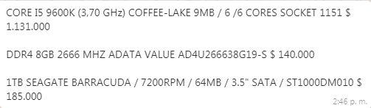

Cometware

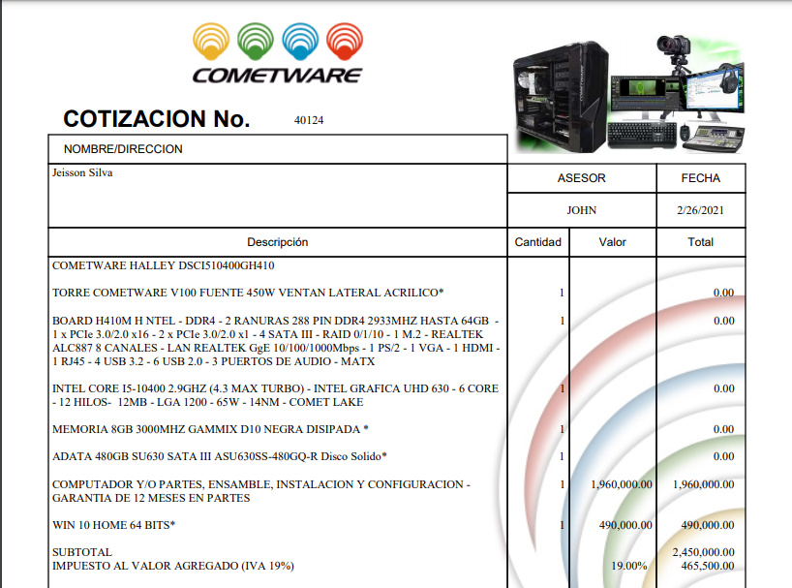

Clones y Perifericos

